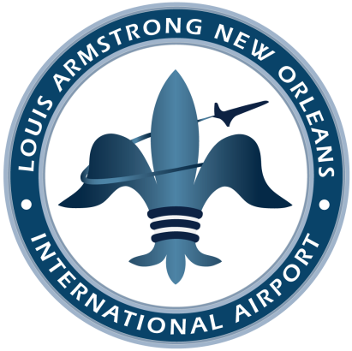

Mayor LaToya Cantrell
City of New Orleans

New Orleans Aviation Board

Hon. Michael G. Bagneris
Chairman

Doug Thornton
Vice-Chairman

Hon. Neil C. Abramson
Todd Francis
Chief Justice (Ret.) Bernette J. Johnson Ruth Kullman
Joseph Nicolosi, Jr.
Roger H. Ogden
Gary L. Smith, Sr.

Kevin C. Dolliole
Director of Aviation

P. O. Box 20007
New Orleans, LA 70141

P: 504-303-7800
F: 504-303-7566

www.flymsy.com
Date

Mr./Mrs. ______
Address

RE:

Dear _______,

Sincerely,

cc:

