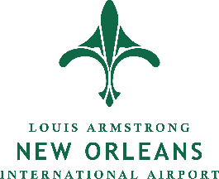
New Orleans International Airport
Americans with Disabilities Act Grievance Form

In accordance with Title II of the Americans with Disabilities Act (ADA) of 1990, the Airport makes all programs and services associated with its operation accessible to all persons with disabilities. Please, use this form to file a grievance if you believe that you were denied access to an Airport program or service based on disability. Submit your grievance to the ADA Coordinator at:

Philistine Ferrand, DBE Liaison Officer
Louis Armstrong New Orleans International Airport
P.O. Box 20007
New Orleans, LA 70141
Office: 504-303-7611 Fax: 504-303-7614
philisti@flymsy.com

Name
Address
Phone Number
E-Mail Address
Date of Incident
Time of Incident
Location of Incident
Name(s) of People Involved
Airport-Affiliated Party Involved
Nature of Incident
Proposed Remedy
Grievance already filed with U.S. Department of Justice, another government agency or in court? Yes No

If Yes, provide contact information of that agency or court and date the grievance was filed. If you have not filed this grievance with the Department of Justice and would like to do so, click here: (https://www.transportation.gov/airconsumer/form-382)

Signature |  | Date

